Laser Design Concept

Satellite altimetry missions use active remote sensing techniques. For that reason the quality of the system is dependent on the emitted electromagnetic radiation and the analysis of the returned signal.

To be able to select any optical emitting device, the important parameters for optimizing the altimetry results should be revised. Several problems occur if emitting radiation is chosen as the remote sensing technique.

1. First of all, general electromagnetic radiation will show isotropic behaviour. This results in an effective energy loss, since most of the radiation is not pointed towards the desired position. Hence, a divergence limited source would be preferable.
2. As mentioned before, the wavelength is an important parameter since it will influence the photons actually reaching Earth. Since the Earth's atmosphere is transparent for wavelengths in the visible spectrum, it would be better to have an electromagnetic radiation source with a wavelength in this interval. Next to that, a regular radiation source (like the Sun) emits radiation consisting of a whole spectrum of wavelengths. The less the number of discrete wavelengths (preferable in the visible spectrum), the higher the quality of the analysis can be.
3. The total work done on the photons to reach the Earth's surface, scatter and return to the receiver is generally very large. To cope with this large work, the energy of the pulses should be high.

Laser Design Options

There are actually many types of laser. The main types are considered below:

1. Helium-Cadmium (He-Cd) gas laser (wavelength 441.6 nm).
2. Neodymium-doped Yttrium Aluminium Garnet (Nd-YAG) solid-stae laser (wavelength 473 nm).
3. Argon (Ar) gas laser (wavelength 454.6 nm).

Laser Trade Off

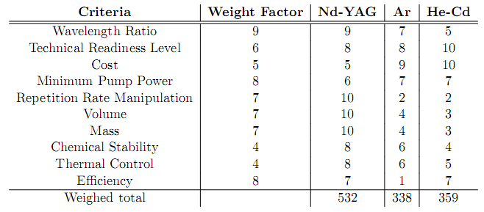

Figure 1: Laser Trade Off

From the trade-off it is obvious which laser should be chosen in this mission. Especially the active pulse manipulation, the chemical stability (directly related to the lifetime) and the mass/volume characteristics are really good for the Nd-YAG laser. The main drawback of the Argon laser is the poor power efficiency, resulting in pump powers in the order of kilowatt's. The main disadvantage of the gas laser in general is the poor performance of pulse manipulation. However, these types of lasers are generally cheaper.

Receiver Design Options

A number of technologies, primarily based on quantum dynamics, and devices are already in production or in development.

1. Micro Photon Detector (MPD)
2. Stereo Imaging Laser Altimeter (SILAT)
3. Single Photon Avalanche Diode (SPAD) + microlenses
4. Single Photon Avalanche Diode (SPAD) + mirrors

Receiver Trade Off

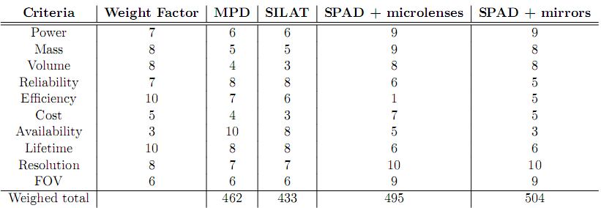

Figure 2: Receiver trade off

The SPAD plus micro lenses and faceted mirror designs have much higher grades than SILAT or MPD. The SPAD with microlenses has the lowest grade for efficiency, which is mentioned in early chapters, because the lenses which are manufactured on the scale of micrometers can only increase the efficiency by factor of 5. On the other hand, the faceted mirror can increase the fill factor from 2% to 80%, which is why faceted mirror has much larger efficiency. Either SPAD design has large advantages on power consumption (100 µW), mass (tens of grams) and volume (5x5x3 mm­­3) comparing to either SILAT or MPD. This means the SPAD is a much more realistic and practical choice if the swarm of receiver satellites are micro- or even nano-satellites. The SPAD with faceted mirror turns out to be the best option when all is considered, and it should be further investigated later on in the detailed design.